Letter of Appointment – Temporary Maternity Leave Cover

<Name>

<Date>

Dear <name>

The following is to assist you in clarifying arrangements regarding this position.

This position is a temporary maternity leave cover position. At the end date of this contract your hours will return to the original hours stated on your Letter of Appointment dated <date>

In the event the employee ceases their maternity leave and returns earlier than originally stated in this contract, the contract will be ceased immediately and your hours will return to the original hours stated on your Letter of Appointment dated <date>

**Commencement date:**

**End date:   
Position:**

**Employment Basis:   
Hours**

**Location of work:** 50 Lalor Street, Portland & in the community

**Accountable to:** Supports Manager **Award:** Kyeema Enterprise Agreement   
  
Contact Supports Manager, Bernie Stiles or Julie Amor for any queries or information.

I wish you well during your time in this position.

**Accepted and signed by employee:**

­­­­­­­­­­­­­­­­­­­-----------------------------------------------------

**Date:**

-----------------------------------------------------

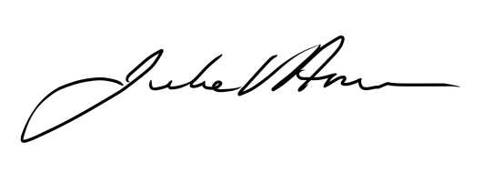Kind Regards,

Julie Amor  
Chief Executive Officer